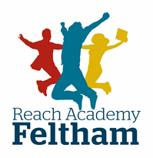
NOTICE OF ADMISSION APPEAL

Please complete the form in black ink, sign and return with any attachments to
admissions@reachacademy.org.uk or to Catherine Tobin, Admissions Team, Reach Academy .53-55 High Street Feltham TW13 4AB.

We/I wish to appeal against the decision not to provide education for my/our child at Reach Academy Feltham
Child’s Surname
Child’s Forename(s)
Date of Birth
Year Group Appealing for

Parent(s)/carer(s) name
Home address &
Postcode
Telephone numbers | Home
 | Work
 | Mobile

We / I will be attending the hearing |  | YES | NO
We / I will be accompanied by a representative
Wheelchair access required
Language/Hearing/ Interpreter required
Representative’s name
Representative’s address

Representative’s telephone number

Note: You will receive notification from the Clerk as to the date and time of the appeal. If you do not attend the hearing your appeal will be decided on the information provided by this form.

We/I agree to less than 14 days’ notice of the appeal hearing  Note: This may help us to slot in late applications for appeal | YES | NO

Please use this space to explain your grounds for appeal (continue onto a separate sheet if necessary)

Please list any attachments sent with this form

Signed ________________________________________ Date ____________________

Print name ____________________________________
For School use:
Date Received
Address verified

